Oracle Form Development:

Oracle Forms Object Navigator
After starting up Oracle Forms, the main screen will be presented.
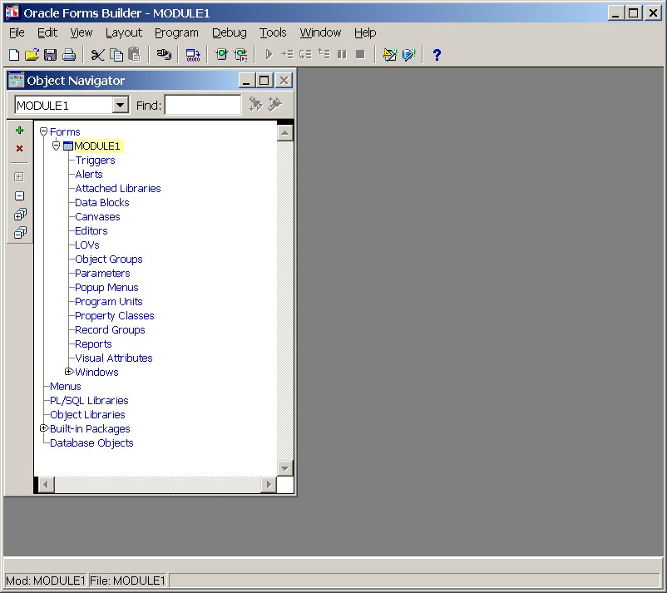
This screen is called the Object Navigator and displays all of the form elements, data blocks, menu items, user defined code libraries, built in procedures and functions, and database objects (tables, views). The display is in the form of a collapsible tree. In general, clicking on a + will expand the current item to show its details. Clicking on a - will collapse the current list details.
The menu bar across the top provides access to almost all of the features of Oracle Forms.
- The File menu has options to create, open, save and print forms. This menu also includes an option to connect to the database and the Administration option that is used to compile forms and menu code. The last option on the File menu is the Exit option that will exit Oracle Forms Builder.
- The Edit menu has options to cut, copy and paste objects, to invoke an editor and to undo an operation.
- The View menu toggles the object navigator display between visual elements and ownership elements.
- The Layout menu has items that control objects on a form much in the way a drawing package does. Objects can be resized, moved, painted and otherwise manipulated using items on this menu.
- The Program menu has items that control form compilation, generation and execution (Run). Triggers, Procedures and other PL/SQL code can also be created from this menu. The Smart Triggers menu option displays the most commonly used triggers according to the type of object currently selected in the object navigator.
- The Debug menu has options for debugging forms as they are running. It includes menu items to establish break points and to step over the execution of code one line at a time.
- The Tools menu has options to switch between several different screens including the Layout editor, Menu editor and Object Navigator. There are also several wizards that can be launched from this menu including the Data Block wizard, the Layout wizard, and the LOV (List of Values) wizard.
- The Windows menu displays menu items for each of the windows you have open. By default, only one item - the Object Navigator - is displayed.
- Finally, the Help menu can be used to display help topics.

The content of the Object Navigator is broken down into 6 major sections:
- Forms - Contains form objects and all of their sub-objects such as data blocks, triggers, alerts, canvases, program units (procedures and functions), parameters and windows. More than one form can be open at a time.
- Menus - Contains menu objects and all of their sub-objects such as menu items, parameters and program units. More than one menu can be open at a time.
- PL/SQL Libraries - These are libraries of PL/SQL code (stored either in the database or in .plb files). Libraries can be shared among different forms and among different developers.
- Object Libraries - These are libraries containing a collection of objects (anything that can appear on a form).
- Built-in Packages - Lists all of the packages (PL/SQL procedures) available by default to all forms, reports, etc.
- Database Objects - Lists all of the database objects (Tables, Views, PL/SQL Libraries, and Stored Program Units) in the user's Oracle database schema.

Creating a New Block
To create a new block, pull down the Tools menu and select the Data Block wizard menu item. The following dialog box will appear:
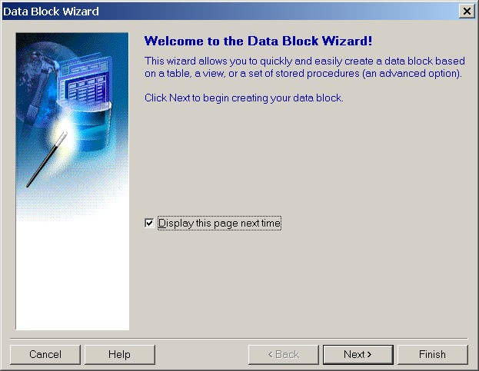
Click on the Next button. The following dialog box will appear:
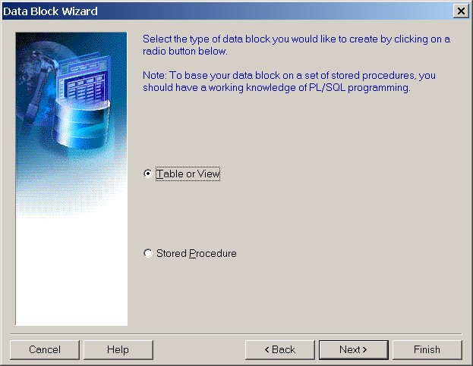
There are two types of data blocks that can be created. Table/View and Procedures. For this example, choose Table/View and click on the Next button.
The next step is to choose a base table and columns that will belong to the data block. The following dialog box should appear:
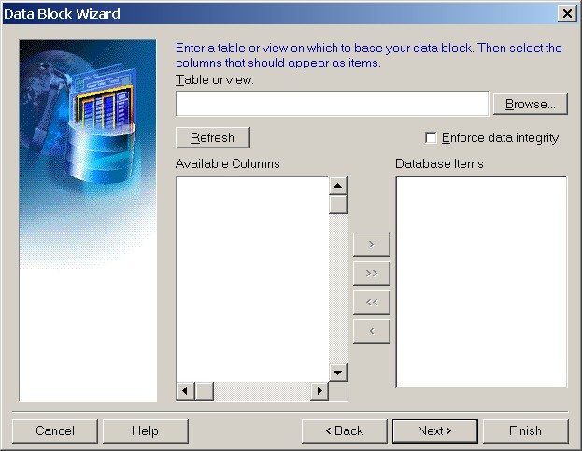
To associate a database table with the block, click on the Browse... button to the right of the Table or View field. The following dialog box will pop up.
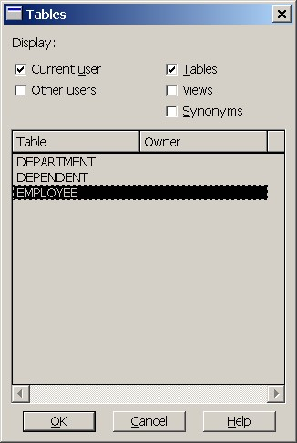
Make sure the Current User and Tables buttons are selected A list of your tables will appear. Highlight the name of the database table (EMPLOYEE in this example) and click on the OK button.
The wizard should reappear with the name of the table and a list of available columns displayed. To include a column in the data block, highlight the column name and click on the right arrow. The name of the column should move over to the right hand side.
For this example, select the FNAME, LNAME, SSN, BDATE, SALARY and DNO as in the following figure:
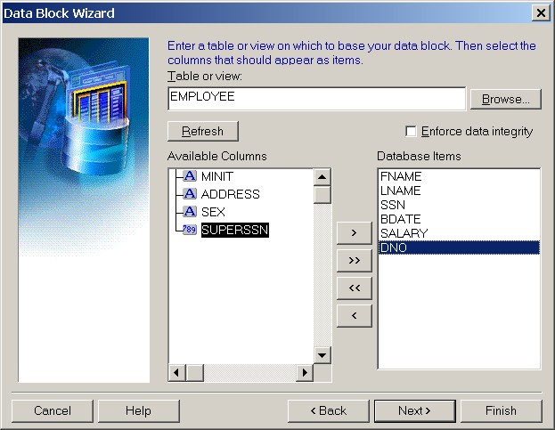
Click on the Next button, a dialog box will appear allowing you to name the data block. In general, it is best to simply use the name of the table as the name of the data block as shown below:
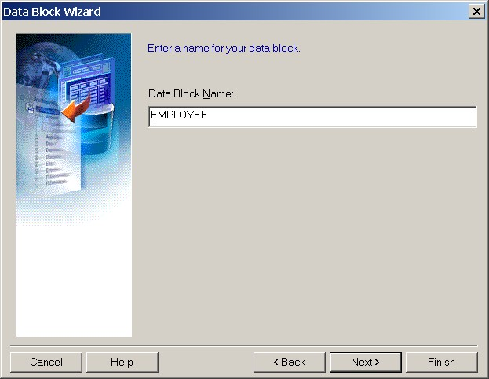
Click the Next button once more and the final dialog box for the Data Block wizard will appear:
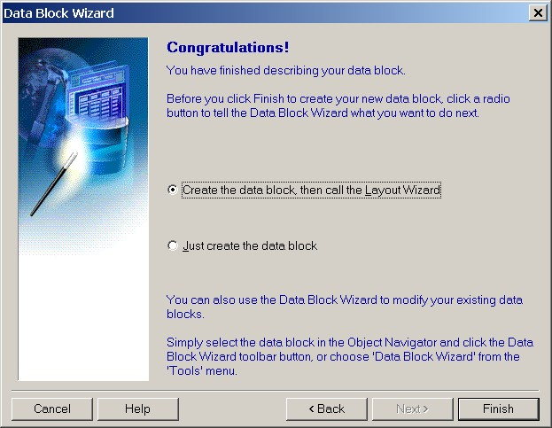
In this example, we want to continue on to the Layout wizard in order to specify how the new form will appear. Make sure the Create the block, then call the Layout wizard option is selected and click on the Finish button.

Creating Layout
Once the new data block and items are created, the first dialog box in the Layout wizard will appear:
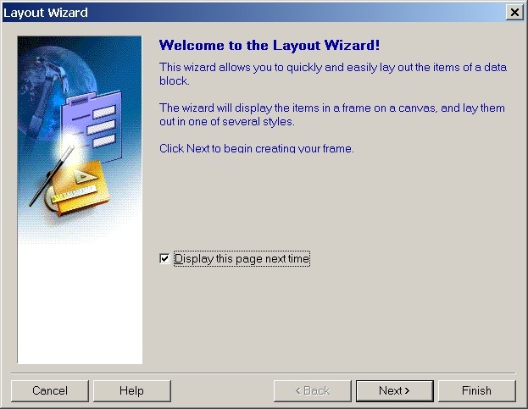
Click on the Next button and the following dialog box will appear:
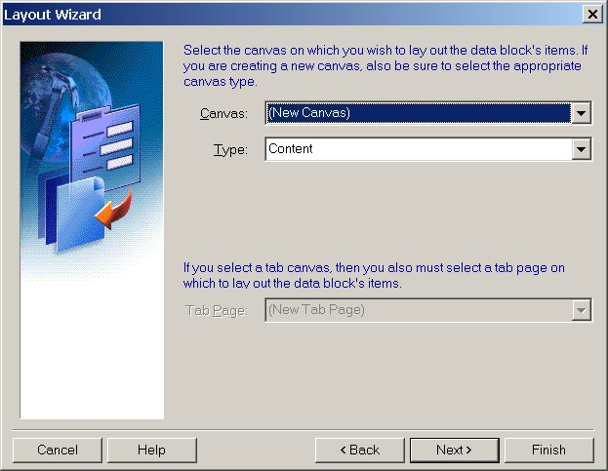
The layout for a data block may be placed on any existing canvas. In this case, there are no existing canvases so the only option available is to create a new canvas.
Click on the Next button to display the following dialog box:
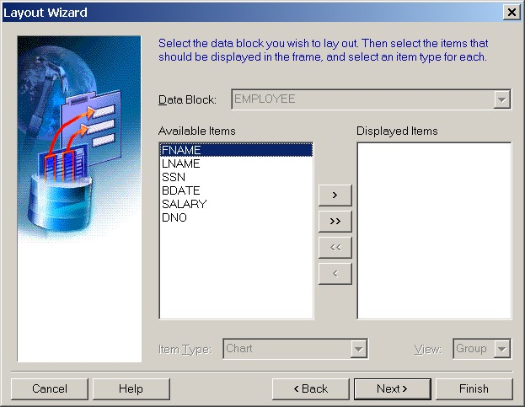
In this dialog box, the columns from a given base table on a data block can be added to the layout. Since we are laying out the EMPLOYEE data block, it is highlighted automatically. Move all of the Available Columns over to the Displayed Items side by clicking on the double right arrow and click on the Next button.
In this dialog box, the field labels, field sizes and field heights can be altered. Change the field labels as shown below and click on the Next button:
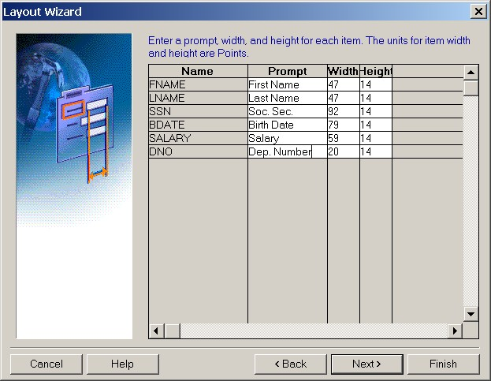
The following dialog box will appear:
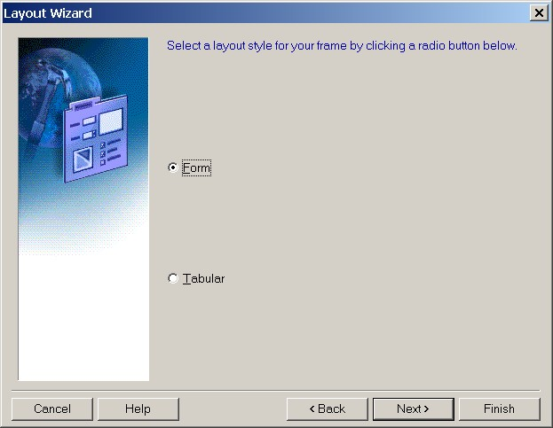
There are two main styles for forms. A Tabular layout arranges the field labels across the top of the form with a number of records below as in a spreadsheet.
A Form layout places the field labels to the left of the fields. Generally only one record is displayed at a time.
In the following dialog box, type a title for the frame (around the data block) and check the option to include a scroll bar.
The number of records displayed for a Form layout should be 1. The number of records displayed in a Tabular layout can be more than 1.
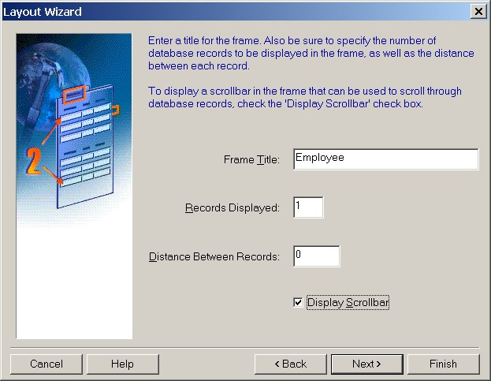
Click on the Next button and the final dialog box for the Layout wizard will appear.
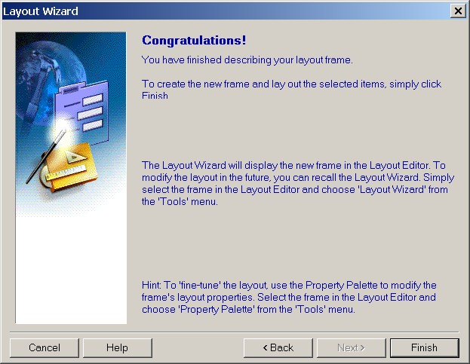
Click on the Finish button to create the layout. A new Canvas will be created with the new block and all of the form items added in the layout wizard.

Creating a Master-Detail Form
A Master/Detail form is a form that has two blocks arranged in a master-detail relationship.

The Master-Detail Relationship
The Master-Detail relationship is a common relationship between entities in a business. In an Entity-Relationship diagram, these are shown as "One to Many" relationships. In a physical database design, a single Master record references one or more detail records in another table. A record in the detail table will relate to exactly one master record in the master table.
Oracle Forms implements the master-detail relationship using two data blocks. The first block corresponds to the master table and the second block corresponds to the detail table. There are two major functions in a Master-Detail form:
- Oracle Forms coordinates values between the two blocks through a series of form and block level triggers.
- Oracle Forms guarantees that the detail block will display only records that are associated with the current record in the master block.
Note that a Master-Detail form is simply one way of viewing the data in two related tables. Forms do not affect the schema in terms of creating, dropping or enforcing database level referential integrity constraints.

Steps to Create a Master-Detail Form

Create the Master Block
In the Object Navigator, click on the Forms branch at the very top. Create a new form by pulling down the File menu and choosing the New menu item. Then choose Form from the flyout menu.
Using the same steps given above create a new block named DEPARTMENT that contains all of the columns in the DEPARTMENT table. Briefly:
- Pull down the Tools menu and choose the Data Block wizard.
- Create a data block for a table/view.
- Specify the DEPARTMENT table and select all of the columns (DNAME, DNUMBER, MGRSSN and MGRSARTDATE).
- Create the data block and then go on to the Layout wizard.
- Apply the Department data block to a new canvas.
- Add all of the columns as Displayed Items.
- Change the labels to:
Dept. Name
Dept. Number
Mgr. Ssn
Mgr. Start Date
- Choose a Form layout.
- Specify a frame title of "Departments" and select only 1 record to be displayed.
- Save the form as deptemp.fmb and then compile and run it to make sure it is working properly.
- Use the QBE features to retrieve only those departments with DNUMBER greater than 2. Then, do another QBE query to retrieve only those departments with the letter H in their name (try %H%).
After this first step, the deptemp form should look like the following:
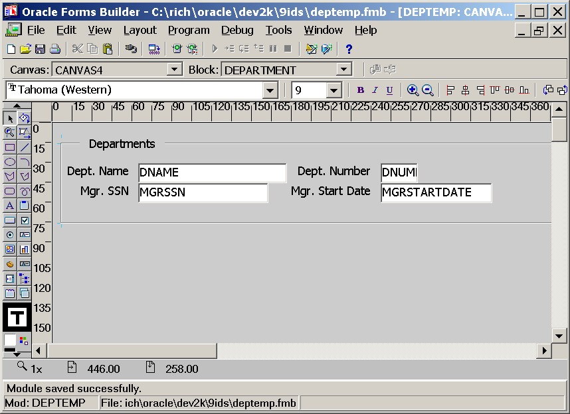

Create the Detail Block
Now that we have the master block DEPARTMENT created, we can now create the detail block EMPLOYEE and associate it with the master block. Perform the following steps:
- Return to the Object Navigator (pull down the Tools menu and choose Object Navigator).
- In the Object Navigator, click on the Data Blocks branch of the DEPTEMP form (do not click on the department data block, however).
- Pull down the Tools menu and choose the Data Block wizard.
Note: If the DEPARTMENT data block (or any of its items) is still selected, activating the Data Block wizard will cause the existing block to be edited instead of creating a new block (which is what is required in this part of the tutorial).
- Select the EMPLOYEE table and include the FNAME, LNAME, SSN, BDATE, SALARY and DNO columns.
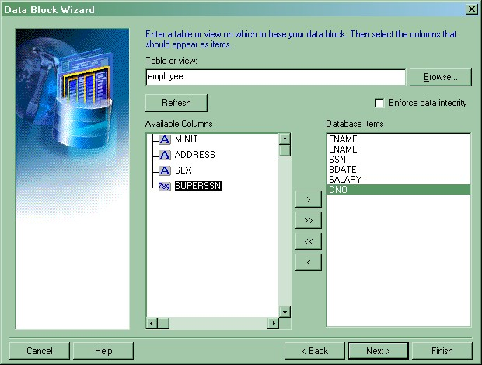
- Because at least one data block already exists in the form, the next step in the wizard will be to create a relationship between the existing data block (DEPARTMENT in this case) and the new block being created.
The wizard can construct the relationship based on table level constraints it learns from the database schema. However, such relationships are not always implemented in table level constraints.
The developer can also specify the relationship manually. In this case, the relationship will be specified manually.
De-select the Auto-join data blocks option.
Click on the Create Relationship button to list the available data blocks.
In the next dialog box Relation Type, choose Based on a join condition and click the OK button.
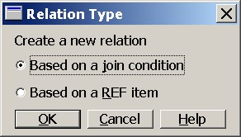
When the list of blocks appears, choose the DEPARTMENT data block.
Arrange the Detail Item (DNO) and Master Item (DNUMBER) such as that the join condition becomes: EMPLOYEE.DNO = DEPARTMENT.DNUMBER
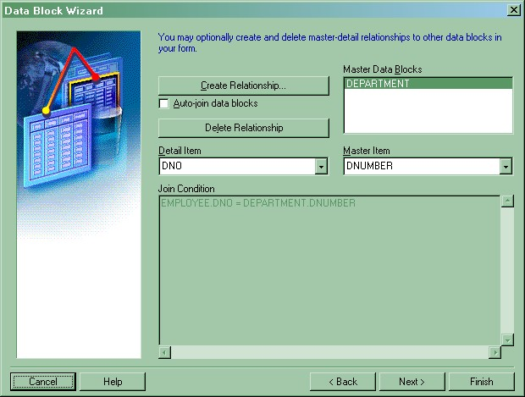
- Name the data block EMPLOYEE.
- Create the data block and then call the Layout wizard.
- Be sure to choose the existing canvas (CANVAS4 in this example) and include all of the items except the DNO as displayed.
The DNO column (item) will still be a part of the EMPLOYEE data block, however, it will not be displayed to the user.
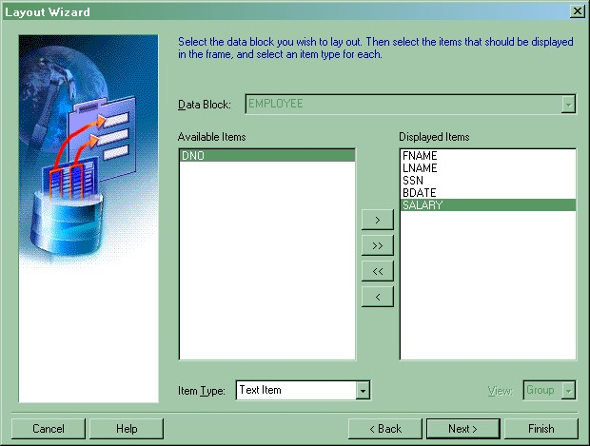
- Touch up the labels for the fields and choose the Tabular layout.
- Give the Frame Title as "Employees" and select 5 Records displayed with 0 distance between records.
- Save the form (it should already have the name deptemp.fmb) and then compile and run it. Note that after compilation, any errors encountered will be displayed.
The following figure shows the master-detail form running:
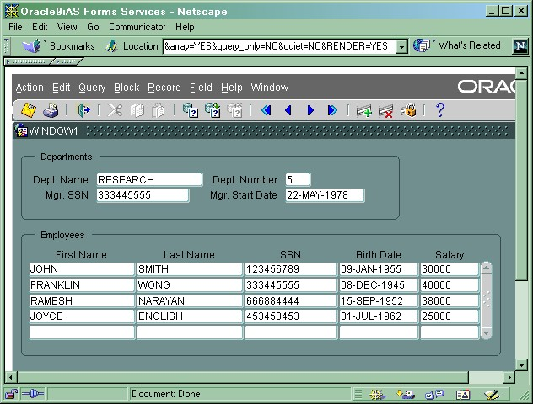
Notice that by scrolling the master block DEPARTMENT to a new department number (using the up and down arrow keys), the employees for that department are automatically queried and displayed.
To navigate between the Master and Detail blocks, use:
- To go to the next block: Press CTRL-PageDown or pull down the Block menu and choose Next
- To go to the previous block: Press CTRL-PageUp or pull down the Block menu and choose Previous

Relation Properties of a Master-Detail Form
There are a number of properties in a master-detail form that can be changed to suit particular behavior of the form. In the figure below, the Object Navigator has several new objects on it including Relations.
To view the properties for the DEPARTMENT_EMPLOYEE relation, open up the DEPARTMENT block and then open the Relations block by clicking on the + symbols. Then click on the DEPARTMENT_EMPLOYEE relation with the right mouse button and select Properties.
There are several interesting properties in the relations property sheet:
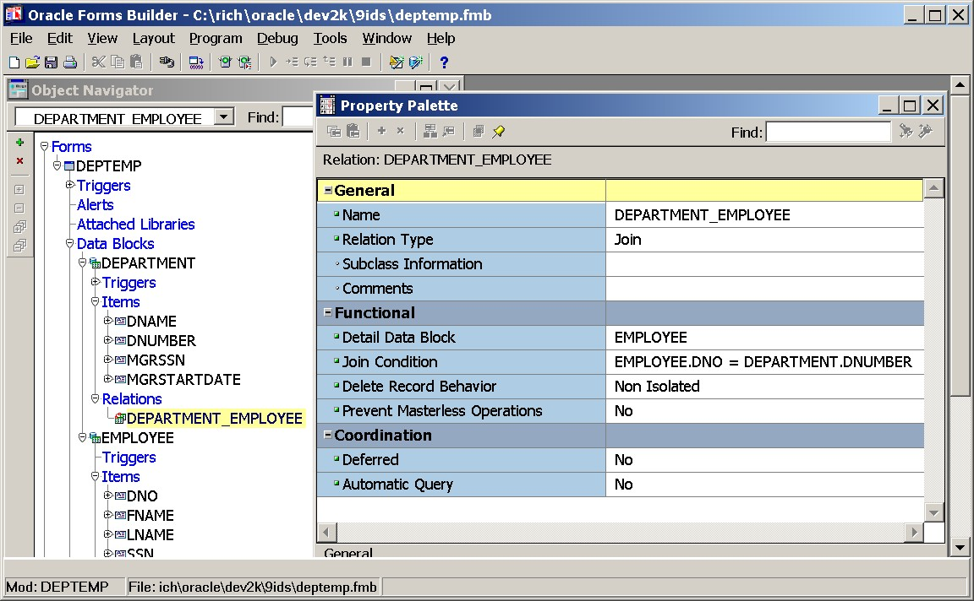
- Name - The name of the Relation. This is typically made up of the names of the blocks.
- Relation Type - The type of the relation: Join or Ref.
A Join relation uses the typical SQL join (in the Where clause) to bring the two tables (data blocks) together. The Ref relation type is used for abstract data types and object references.
- Detail Data Block - The name of the detail data block specified when the detail data block was created.
- Join Condition - This is the join condition in effect for queries to the database. This was specified when the detail data block was created.
- Delete Record Behavior - Used to specify how the deletion of a record in the master block affects records in the detail block. It supports the following settings:
  - Non-isolated: Prevents the deletion of a master record if associated detail records exist in the database.
  - Isolated: Deleting the master record will not affect the associated detail records in the database.
  - Cascading: Deletes the master record and automatically deletes any associated detail records.
- Coordination - Deferred - Indicates when detail records should be queried when a master record is queried.
  - Yes: Form does not query the detail records until the user navigates to the detail block.
  - No: Detail records are fetched immediately when a user queries the master record.
Deferred is sometimes set to Yes in cases where there are a lot of detail records for each master record. In such cases, a lot of data must be queried and delivered to the client each time a new record is displayed in the master block. When Deferred is set to Yes, the user can scroll down to the master record of interest and then navigate to the detail block (CTRL-PageDown) to query the related detail records.
- Coordination - Auto-query - Applied to deferred queries only
  - Yes: the query is automatically executed when the user navigates to the detail block.
  - No: the query must be executed manually by the user after they navigate to the detail block.
- Prevent Masterless operation - Specifies whether users are allowed to query or insert records in a detail block when no master record is in place.
  - Yes: Users may not query or insert when no master record is in place.
  - No: Users may query or insert when no master record is in place.

